## **UTILITY SHUT-OFF PHOTOGRAPHS**

**2019/2020**

*Sample Photographs*

**GAS SHUT-OFF VALVE (SAMPLE)**

***Provide written location(s) of your school’s main gas shut-off valves***

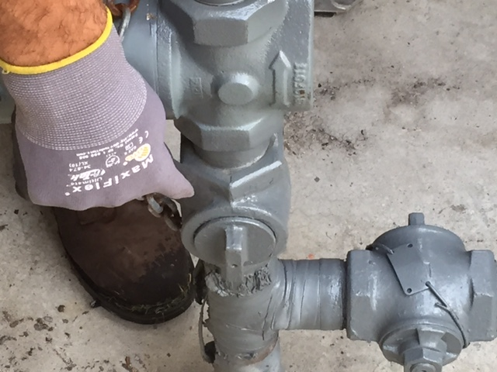 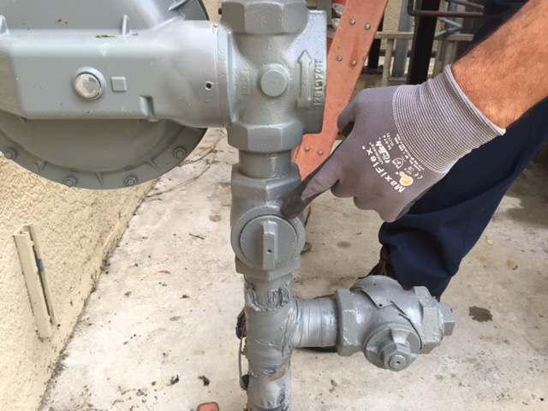

Not a Shut-Off Valve (sample)

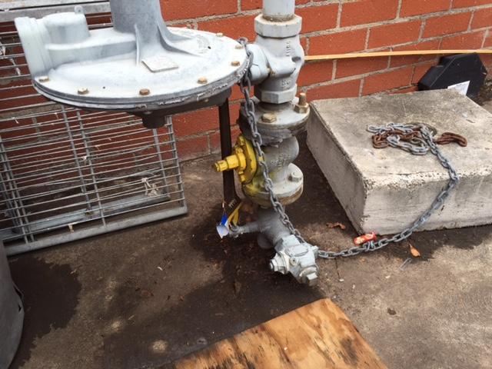

Shut-off Valve Painted Yellow (sample)

**ELECTRICITY SHUT-OFF SWITCH (SAMPLE)**

***Provide written location(s) of your school’s main electrical shut-off switches***

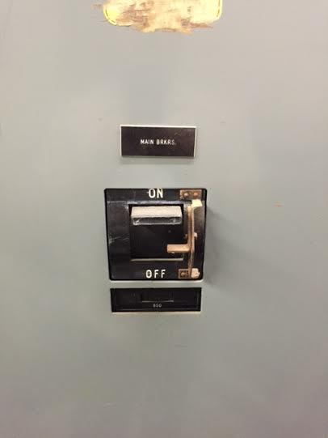

Main Circuit Breaker – Pull Down (sample)

**WATER SHUT-OFF VALVE (SAMPLE)**

***Provide written location(s) of your school’s main water shut-off valves***

