**Aesop 101**

* **How to get to Aesop**
  + <https://iusd.aesoponline.com/>
  + <http://iusd.org/>
    - Human Resources>Employee Absence Substitute Management System
  + <https://intranet.iusd.org/>

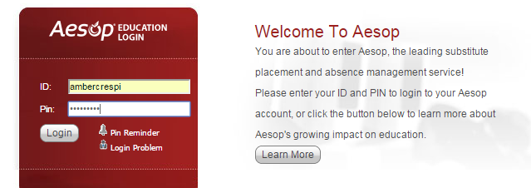

ID: firstlastname

Pin: password for an IUSD computer/email

* **Training**
  + <http://timereporting.iusd.org/>
* **Home Screen**

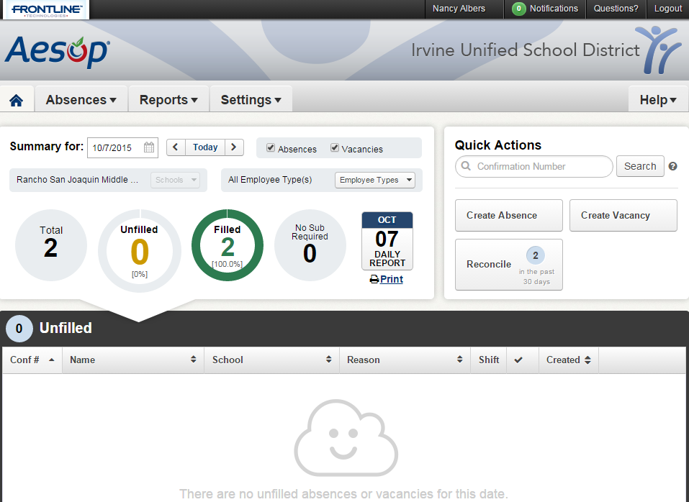

* + Absences
    - Creating an Absence or Vacancy

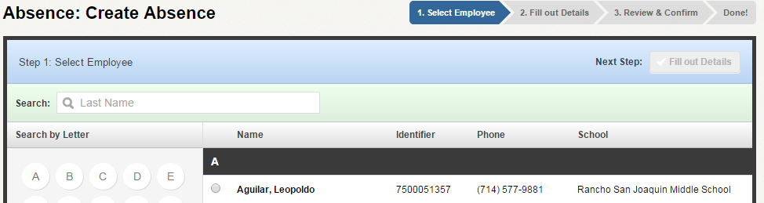

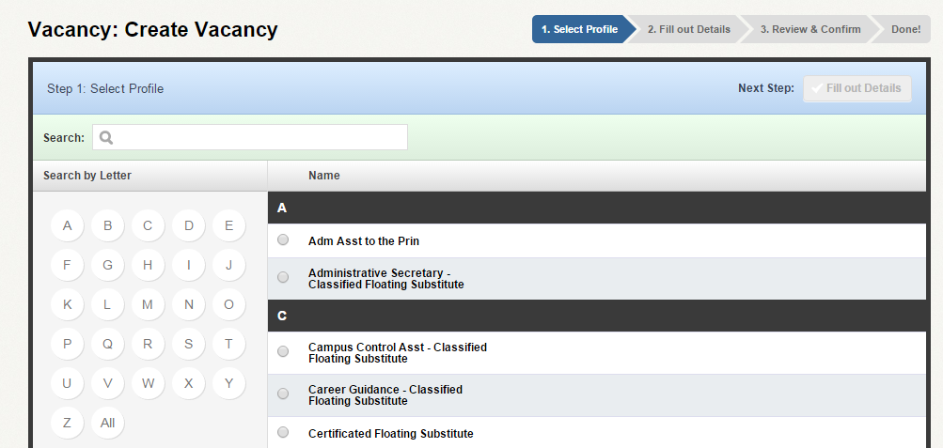

* + Reports
  + Settings
    - Preferred Substitutes

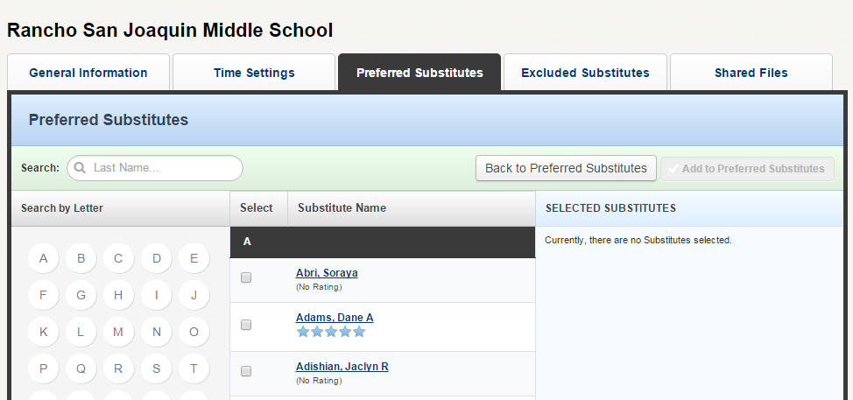

* + Daily Report

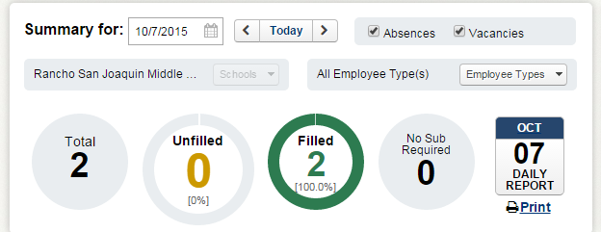

* + Reconcile

