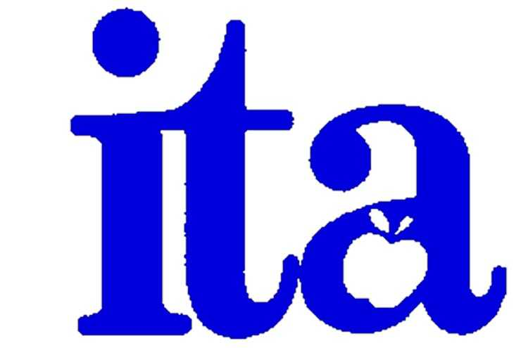

CTA/**nea**



**ITA/IUSD**

**Negotiations Update**

**⯁ March 17, 2011 ⯁**

***A Joint Communiqué from the***

***ITA and IUSD Bargaining Teams …***

**Continuing with the Mutualistic Approach**

***Research shows that the most successful organizations treat the management-labor relationship as a partnership. This requires a paradigm shift from “us and them” to “we.”***

***Thanks to our commitment to this collaborative, problem-solving model, over the past few years we have been able to reach satisfactory bargaining settlements and resolve many issues involving district employees. In these financially difficult times, we remain committed to using this process as we face the many challenges ahead in next few years.***

**Principles**

|  |  |
| --- | --- |
| * Mutual Respect and Professionalism * Honesty and Integrity | * Strong and Straight-Forward Communication * Collaborative Problem Solving |

**Process**

* Communicate Topics/Issues for bargaining
* Identify facts and perspectives around Topics/Issues (i.e. “The Story”)
* Articulate the Interests and needs of each party
* Brainstorm potential Options
* Research and collect data related to Options
* Evaluate Options to best meet the Interests and needs of both parties
* Attempt to reach consensus on Options that resolve Topics/Issues

**Goals**

* Long-term positive change in the ITA and Management relationships throughout the District
* Settlements based upon principles and mutuality, not power and crisis activities
* Use of this problem-solving model throughout the District

**Summary of Topics Identified on March 17, 2011**

|  |  |
| --- | --- |
| * Arts Advantage * Coaching Shares * Compensation * Class Size * Disciplinary Process * District Contribution for Health Benefits * “Early Out” Wednesdays * Evaluation | * IEP time * Middle School “Late Starts” * Parent/Guardian Complaints * PAR * RTI * Shared Contracts * Summer School * Surplus Language |

**Where Are We Now?**

When the bargaining teams met on March 17th, we initiated preliminary discussions on the diverse issues, generated some conceptual agreements, and identified areas where we need more information.

Implementation of the RtI model is one of the issues that was discussed and identified as being more complex. RtI is a federally mandated program that has been implemented in “waves” across the District over the last four (4) years. In an effort to facilitate district-wide success, a survey is being collaboratively developed by ITA and the District to solicit your input regarding, among other things, what is working, what needs improvement and what kinds of support you would find helpful.  Please take the time to complete the survey when it comes out. Your feedback and suggestions will be invaluable in enhancing our understanding of the challenges and successes of this program and using these insights to support schools in implementing this model.

We will also collaborate on a survey to solicit your input regarding other district programs, including the Arts Advantage curriculum.

**Next Steps**

* Meet again on April 1st and 15th.
* Continue to engage in dialogue on the Topics
* Upon receipt of feedback from constituents and data gathered, continue discussing and begin to evaluate Options for the various Topics in an attempt to reach consensus

**Team Members**

**ITA Bargaining Team:**

* Anne Caenn, Chair, Venado Middle School
* Liz Harlow, Canyon View Elementary School
* Tim Jamison, Bonita Canyon Elementary
* Lauren Pipp, Bonita Canyon Elementary School
* Alan Simsovic, Northwood High School

**Additional Team Support:**

* Laurie Atkinson, Executive Director, Irvine/Tustin Teachers UniServ/CTA/NEA
* Rick Seibert, President, Irvine Teachers Association

**District Bargaining Team:**

* Terry Walker, Assistant Superintendent, Human Resources
* Susie Kemp, Principal, Canyon View Elementary School
* John Pehrson, Principal, University High School
* Rena Thompson, Director, Human Resources
* Scott Bowman, Principal, Rancho San Joaquin Middle School

**Additional Team Support:**

* Lisa Howell, Assistant Superintendent, Fiscal Services
* Susana Lopez, Director, Fiscal Services
* John Rajcic, Labor Consultant
* Ruth Romero, Confidential Secretary, Human Resources